**Data Architecture Overview**

**1. Introduction**

**1.1 Definition of Data Architecture**

Data architecture is the overarching design of an organization's data assets, defining how data is collected, stored, processed, and utilized.

**2. Data Warehouse**

**2.1 Definition**

A Data Warehouse is a comprehensive and centralized repository designed to collect, store, and manage vast volumes of structured and sometimes semi-structured data originating from various sources within an organization. It serves as a fundamental component of an enterprise's information architecture, strategically crafted to facilitate efficient data analysis, business intelligence, and reporting.

**2.2** **Data Warehouse** **Architecture**

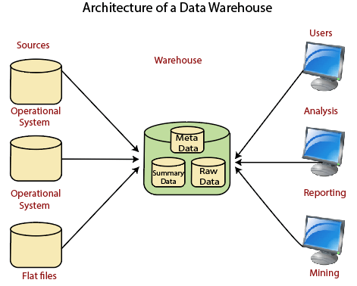

**2.3 Characteristics**

- Structured Data: Typically stores highly structured data.

- ETL Processes: Involves Extract, Transform, Load processes for data integration.

- Optimized for Reporting: Designed for efficient querying and reporting.

**2.4 Components**

- Data Sources: Where data is extracted from.

- Data Warehouse Database: Where transformed and integrated data is stored.

- ETL Tools: Software for Extract, Transform, Load processes.

**2.5 Advantages**

- Provides a single source of truth.

- Supports historical data analysis.

- Enhances decision-making through data-driven insights.

**2.6 Challenges**

- High cost and complexity of implementation.

- May not be suitable for handling unstructured data.

**3. Data Lake**

**3.1 Definition**

A Data Lake is a comprehensive and centralized data storage repository that facilitates the accumulation, ingestion, and storage of vast volumes of both structured and unstructured data without predetermined schema enforcement, providing an environment conducive to the storage and processing of data at virtually any scale. Unlike traditional data storage systems, which typically require structured data formats and schemas prior to ingestion, a Data Lake employs a "schema-on-read" approach. This means that the data is stored in its raw and native form, and the schema is applied or interpreted only when the data is accessed or queried.

**3.2 Data Lake Architecture**

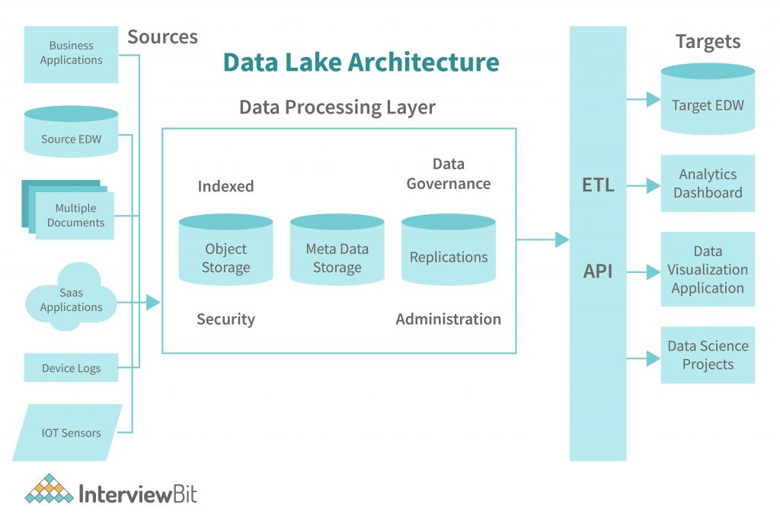

**3.3 Characteristics**

- Schema-on-Read: Supports storing raw, unstructured data and applies schema when needed.

- Scalability: Can handle large volumes of data.

- Flexible: Accommodates various data types and formats.

**3.4 Components**

- Storage Layer: Cloud-based or on-premise storage infrastructure.

- Data Ingestion Tools: Tools for ingesting raw data.

- Metadata Store: Catalogs metadata for efficient data discovery.

**3.5 Advantages**

- Supports diverse data types and formats.

- Enables advanced analytics and machine learning.

- Scales horizontally to accommodate growing data volumes.

**3.6 Challenges**

- Governance and data quality concerns.

- May require strong metadata management.

**4. Data Mesh**

**4.1 Definition**

Data Mesh is an architectural paradigm that focuses on decentralizing data ownership and architecture. It represents a shift from the traditional centralized data approach to a more distributed and domain-oriented model.

**4.2 Data Mesh Architecture**

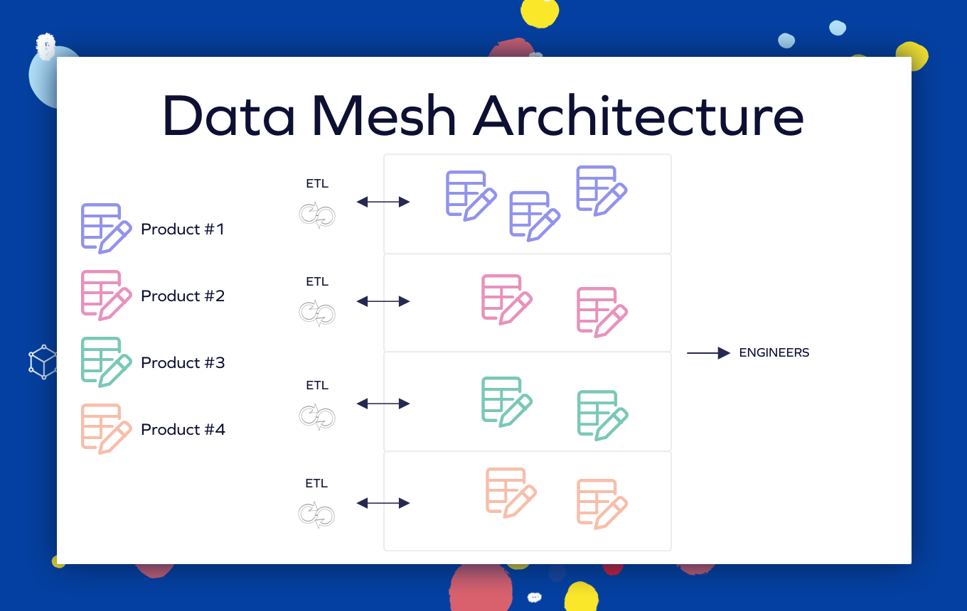

**4.3 Characteristics**

- Domain-Oriented Data Ownership: Individual domains own and manage their data.

- Federated Architecture: Each domain operates as an independent data product.

- Data as a Product: Treats data as a product with defined APIs and standards.

**4.4 Components**

- Domain Data Products: Independent data products managed by individual domains.

- Data Mesh Platform: Infrastructure supporting decentralized data products.

- Data Product APIs: Standardized interfaces for interacting with data products.

**4.5 Advantages**

- Distributed data ownership improves agility.

- Facilitates scalability and autonomy of data domains.

- Aligns with a microservices-oriented approach to data.

**4.6 Challenges**

- Requires a cultural shift towards domain-oriented thinking.

- Complex governance and coordination across decentralized teams.

**5. Conclusion**

Data Warehouse, Data Lake, and Data Mesh architectures provide different approaches to managing and utilizing organizational data. The choice depends on the specific needs, scale, and goals of the organization.